Unit 2 Study Guide
- Be able to identify evidence that supports the defining moments in each of the following stories:
*Tool to use: Synthesis Chart for Unit 2
  - Where I’m From
  - Funny in Farsi
  - Kaffir Boy
  - Pick One
  - Persepolis
  - Grape Sherbet
  - Thanksgiving: A Personal History

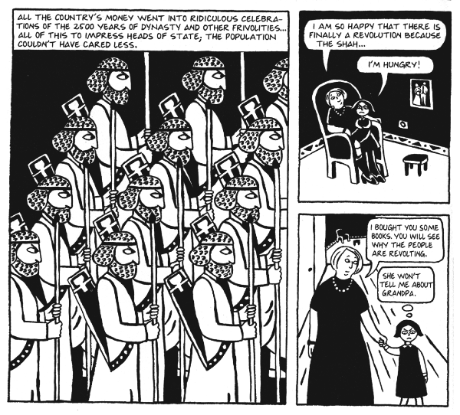
- Be able to label the following elements of a graphic novel:
*Tool to use: Literary Term Chart (green paper)
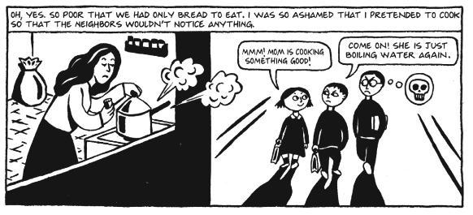
  - Panel, Gutters, Dialogue Balloons, Thought Bubbles, Captions, Sound Effects

- Be able to define and identify examples of the following literary terms:
*Tool to use: Literary Term Chart (green paper)

Anaphora
Memoir
Syntax
Setting
Dynamic Character
Static Character
Point of View
Sequence of Events
Theme
Persona
Imagery
Diction
Denotation
Connotation
Allusion

For 1 selection you haven’t read before, you will be asked questions including but not limited to the following:
- Author’s choices/stylistic choices such as use of descriptive language and its effects
- Influences on the narrator of a story
- Identifying evidence to support your answers to questions
- Writing a theme statement using the framework we have practiced in class

For 1 selection you have read in class, you will be asked to write in a CEI paragraph response to the following prompt:
“What is the defining moment of the narrator?”

