Hillgrove High School Senior Capstone
Student Handbook 2019-2020

Table of Contents

THE SENIOR PROJECT AT HILLGROVE HIGH SCHOOL ……………………………………..2
PACING GUIDE
Fall Semester……..………………………………………………………………………………………..3
Spring Semester……………………………………………………………………………………………4
REQUIREMENTS FOR SUCCESSFUL COMPLETION OF SENIOR PROJECT……………5
CONSEQUENCES of FAILURE to MEET DEADLINES……………………………………………..6
TOPIC SELECTION GUIDELINES …………………………………………………………………………7
PRESENTATIONS: A GUIDE……………………………………………………………………………..….8
SUGGESTED PRESENTATION GUIDELINES………………….…………………………………………………………………………………….9-10
LETTER TO THE JUDGES FORMAT....…………………………………………………………………..11

The Senior Project at Hillgrove High School

Senior Capstone Overview

The Senior Capstone is a fitting conclusion to your high school education as it provides an opportunity for you to demonstrate what you know and to showcase your achievement. It must be successfully completed as a 20% component of your senior English class, which is required for all graduating seniors.

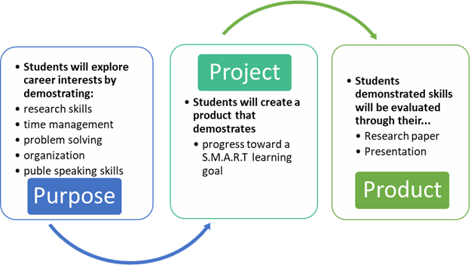

Fall 2019 Pacing Guide

August 1-15 | Introduce Capstone Project; Youscience review; Identify topic & mentor; Begin mentor hours;
8/23 | Proposals (Final On-Time Proposal)
9/1-23 | Work on research paper in English classes
9/30 | Research paper due
9/20 | 5 Hour Check (Mentor Check #1) Lock-in product as a part of Verification
9/28 | Schoolwide proposal presentation with paired faculty member  (in homerooms)
10/5 | Final Research Paper due
10/18 | 10 Hour Check (Mentor Check #2)
10/25 | Final deadline. All materials are to be complete:  · 10 mentor hours & Mentor Verification  · Research Paper  · Proposal Approval  · Mentor Evaluation  · Reflection  · Resume
11/7 | Schoolwide presentations with paired faculty member  (During Hawkhours)
11/11- 11/15 | Practice Presentations (in-class and dress rehearsals)
11/21 | Capstone Boards Night
11/22 | Capstone Celebration

Spring 2020 Pacing Guide
January- February | Introduce Capstone Project; Students work on finding a mentor and brainstorming about products; Begin mentor hours; Work on research papers
2/1- 2/15 | Proposals
2/26 | Mentor Check #1 (Minimum 5 hours due) WITH Mentor Verification; Lock-in product as a part of Verification
3/12 | Final Research Paper due
3/19 | Mentor Check #2 (Minimum 10 hours due)
3/26 | Final deadline. All materials are to be complete:  · 10 mentor hours & Mentor Verification  · Research Paper  · Proposal Approval  · Mentor Evaluation  · Reflection  · Resume
4/8-4/12 | Practice Presentations (in-class and dress rehearsals)
4/ 18 | Capstone Boards Night
4/ 19 | Capstone Celebration

Process for Successful Completion of Senior Capstone

RESEARCH PAPER:
Requirements:
- Expository or persuasive research
- APA Style
- Final Draft 3-5 pages with at least 5 sources

Required Process Steps:
- Research question
- Idea sheet
- Annotated bibliography
- Outline
- Rough draft

PRESENTATION
Requirements:
- Between 8 and 10 minutes long
- Judged on content and delivery
- Appropriate business-style dress
- Visual to enhance understanding of product

Required Process Steps:
- Proposal
  - Identifies mentor, product, and stretch

- 10 verified hours with a valid mentor through video documentation
  - Must be 21 years of age or older
  - Expert in their field
  - Cannot be a relative
  - Cannot be a member of the faculty
  - Initial mentor contact is the responsibility of the student. Your senior English teacher will not make initial contact with your mentor for you!

- Product
  - Product may be something that is made, an experience-based portfolio, a skill that is learned, or a service performed for the community
  - Product must present a learning stretch, taking you beyond what you have ever done before
  - Product related to research

Consequence AcknowledgementThe purpose of Senior Capstone is to allow students the opportunity to explore careers of their choice. An important part of this exploration includes practicing professionalism. Among these skills are time management, problem solving, clear communication, and organization. The Capstone is broken into manageable segments with required deadlines* that help support this purpose. If a deadline is not met, the consequences are outlined below.
· A student must complete each assigned component of the Capstone on time to avoid penalty in the form of point deduction.
· If a student feels that s/he has a legitimate excuse for being late on a component and should not be penalized, appropriate appeal should be made to their Senior Capstone instructor. Some requests may require approval from the Senior Capstone Collaborative Committee.
Below you will find specific consequences for the 2 major areas of the project:
Research Paper:
1. Failure to meet a research deadline will result in a penalty of 10 points (or 10%) for each day late up to 3 days; after the third late day, the final grade on that component will be a zero.
2. Students who are caught cheating on any component of their research paper will be required to rewrite their paper with a 10% penalty(10% of the grade).
Mentor Hours/Product:
1. Students are responsible for completing a minimum of 10 (8 hours must be face-to-face) hours with their mentor. For students who complete less than 5 hours, a grade of zero will be received for the presentation and the student will not present on boards night.
2. A student must complete each mentor check (proposal, 5 hour check, 10 hour check) on time to avoid a penalty. If a student has more than one late mentor check, the student will have a 10 point deduction on the final presentation
3. Products that have been approved may not be changed without a conference with their Senior Capstone instructor.
*deadlines are set by the Capstone Collaborative Committee and are not at the discretion of individual teachers.
**The Consequence Form must be submitted with parent and student signature in order begin receiving Senior Capstone grade. All grades associated with Senior Capstone will receive a grade of zero until the form is submitted
I understand the above information and agree to accept the consequences for failing to comply with the requirements.

Signature of Student:___________________________________________ Date:____________

I understand the responsibilities of my son/ daughter in submitting materials by the deadlines established and in maintaining academic honest and integrity.

Signature of Parent:_____________________________________________ Date:___________

Topic Selection Guidelines

- The topic should be one in which you are highly interested, but not yet an expert. Consider topics that are related to a career interest, career aptitude, or life skill.
- The topic should be broad enough to allow you access to enough information, but narrow enough to make the research scope reasonable. For example, a student investigating business management would find it impossible to include everything related to the topic. Rather, it would be more appropriate to explore a specific facet of the business industry such as the use of technology to manage a small business.
- Avoid choosing topics that might involve expenses that you are not prepared to handle. There is no required expenditure for the research or the product. Keep in mind that your grade on the research/product is not affected by your expenditures.
- Topics that are illegal, dangerous to you or to someone else, or prohibited by Cobb County schools will not be approved. Non-traditional topics will be addressed on an individual student basis.

Guidelines for Product Development

Product You Make:

Identify the specific product to be made

Showcases the physical process

Documented through picture, video, and tangible product

Skill You Learn:

Identify the specific skill to acquire

Showcases development of the skill over time

Documented through evaluation, picture, video, and demonstration

If skill includes working with another individual (coaching, teaching, personal training)- progress of individual should be documented (charts, pre-/post-tests, and/or videos)

You may not coach, teach, or train yourself. You may not be your own product

Service You Provide To Community/ Event Planning:

Identify the specific goal of the service or event

Held prior to the conclusion of the 10 hour deadline

Demonstrate the planning, organization, communication, and marketing of event

Documented through picture, video, interviews, personal reflections, and participant feedback/ surveys

Knowledge You Gain Through Experience-Based Learning:

Identify a learning objective

Develops an interactive style portfolio to showcase learning

Documented through comprehensive field notes/ journal, picture, video, and interviews

Presentations: A Guide
Three areas of consideration for your presentation should be
- Visual
- Content / Talking Points
- Delivery & Appearance

III. DELIVERY & APPEARANCE
A. Delivery
- Note cards may be used, but they should not be read; use your visual outline as you proceed through your presentation (by pointing to items as you speak).
- Feel free to walk around a bit, within a defined area.
- Use your hands to gesture for emphasis if you are comfortable enough to do so.
- Use voice inflection and repetition to highlight important points and to keep interest.
- Make eye-contact with all of the judges -- not just one.
- Face the audience at all times! Do not turn your back on your audience to look at a TV screen or an overhead projection.
B. Appearance

You should be clean and well-groomed.
2. You should be dressed in a manner appropriate for a business presentation.

Further Suggestions for Presentations

From Toastmasters International Better Speaker Series
Requirements: The student is required to present an eight to ten minute speech with visual aids before a panel of judges. He or she should wear appropriate business attire. Students should avoid dressing as they would for a party or date.

Planning the Speech: The student should complete an outline to help organize the speech. It will help to write the main points of the speech on note cards and use those cards when practicing. Sufficient practice is the key to a good speech. Students should time the speech when practicing so they know the time limit is acceptable. Delivery techniques include: 1) speaking slowly and clearly 2) knowing the material 3) making frequent eye contact with the judges and 4) not reading from cards or a script.

Suggested Presentation Guidelines

How to Create TED Style Talks: https://www.ted.com/talks/chris_anderson_teds_secret_to_great_public_speaking/up-next?language=en#t-494643

Four Main Points To Remember:
- Talk about one central idea
- Give your audience a reason to care (spark their curiosity- question what people know)
- Build your idea (explain your process- make the simple exciting- make the complex simple)
- Make your idea worth sharing (Who does this idea benefit? How can it change perspective?)

The big idea of my project is _______________________________________________________

How do I want to influence the audience’s thinking? What do I want them to understand that may be different?

How can I relate this big idea to my audience (story, video, demonstration, metaphor, etc)?

What is my big reflection? What did I learn about myself or the world?

Suggested Presentation Guidelines

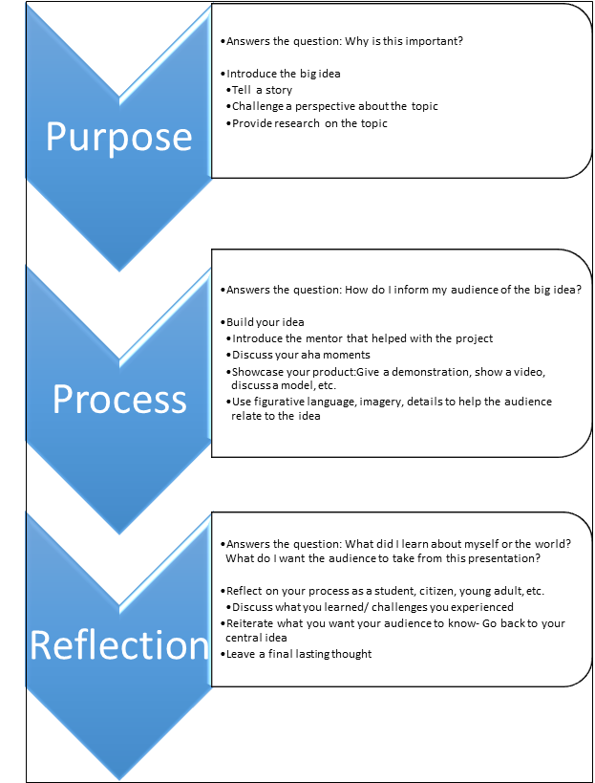

Letter to the Judges Format
Your name
1550 Owens Store Road
Canton, GA 30115
Date
Judges, Senior Project
Hillgrove High School
4165 Luther Ward Road
Powder Springs, GA 30127
Dear Judges:
Paragraph 1:
Briefly introduce yourself, your goals (the learning goal/ objective )– your choice for your senior capstone. This is where you put your big idea. Briefly discuss your research.
Paragraph 2:
- Explain how you decided on your senior capstone and how it relates to a career you hope(d) to pursue. Then, briefly describe your process and your product (discussion of the showcase). (5 sentences max)
Paragraph 3:
First, discuss successes and/or challenges you encountered over the course of this process. Then, answer either a or b.
a) What skills or experiences have you acquired that will better prepare you for pursuing a career in this field?
b) How did this experience help you realize you wanted to pursue a different career path?
Paragraph 4:
Explain what you learned about yourself through senior capstone (your reflection), your postsecondary plans, and then thank the judges for their time.
Sincerely,
Your Name

Hillgrove High School

SENIOR CAPSTONE

2019- 2020

Principal
Angela Stewart

Senior Project Steering Committee
Assistant Principal for Senior Project: Mark Giles
Senior Project Collaborative Team: Ryan Broome, Emily Ellwood, Alani Ramos,
Aliyyah Salam, Dave Thomas, Wendy Walker
Operations: Katherine Brink
English Department Chair: Sylvia Spruill
Judges Coordinator: Kelly Colvin

4165 Luther Ward Road
Powder Springs, GA 30127
678-331-3961
678-331-8128 fax

